Business Template

Subject areas
Logo / Image

DB_Liziko_Mamaladze_HW
SOCIAL MEDIA PLATFORMS

Contents
Business Description 3
1.1 the Benefits of implementing a database. Project Vision 3
2 Model description 3
2.1 Definitions & Acronyms 3
2.2 Logical Scheme 3
2.3 Objects 3

Business Description

the Benefits of implementing a database. Project Vision
To answer these questions, you can rely on the following questions:
- How will the database solve the problems listed in the description?
- How will it ensure data integrity, consistency, and traceability?
- How does your model store the history of changes?
- How does your structure allow the system to scale without major redesign?
- Which constraints and checks have you added to keep data correct as volume grows?

The purpose of this project is to design a logical data model for a social media platform that supports typical user interactions such as creating posts, commenting, liking content, following other users, and sharing posts across different platforms. The database structure was designed to represent the main functional components of a social media system while reducing redundancy, ensuring data consistency, scalability, and the ability to preserve historical information about user activities. Social media platforms involve multiple interconnected activities such as publishing posts, interacting with content, and maintaining relationships between users. Without a structured database model, storing and managing this information would quickly become inconsistent and difficult to maintain.

The modeling process began with identifying the core entities that represent the main components within the system. The central entity in the model is the User entity, which represents individuals who have created a profile and interact with the platform. Since users perform various activities, most other entities in the system are directly or indirectly connected to the User table.

Another important entity that I identified early in the design process is the Post table. This table represents the main content created by users and serves as the primary object of interaction within the system. Most user activities in the platform revolve around posts, which is why several other entities are connected to it.

To ensure data integrity, consistency, and traceability, the database was designed following relational database principles and normalization rules. During the modeling process, I structured the schema so that it aligns with the principles of Third Normal Form (3NF). In this structure, each table represents a single real-world concept and every attribute depends only on the primary key of that table. Each record in the system is uniquely identified, and relationships between entities are defined according to the logical behavior of the platform. For example, a single user can create multiple posts and perform multiple interactions, which results in one-to-many relationships between users and different activities. In situations where both entities can be related to multiple records of the other entity, I used bridge tables to represent many-to-many relationships while maintaining normalization and data consistency. This ensures that all interactions stored in the system correspond to valid users, valid content, and valid relationships. As the platform grows and more records are stored, these structural rules help prevent inconsistencies. (A more detailed explanation of these relationships will be provided in the following sections.)

Another important aspect I considered during the design was the ability to preserve the history of user actions and changes. Social media platforms generate continuous interactions, and many of these actions may later be reversed or removed. Instead of permanently deleting records, the model stores timestamps that indicate when actions occur and when they become inactive. This approach allows the system to maintain a complete history of events such as user interactions, post availability, or follow and unfollow actions. Keeping this historical information improves traceability and also makes it possible to analyze past user behavior or reconstruct previous states of the platform if needed.

To ensure that the database maintains correct and reliable data as the number of records increases, I incorporated several types of constraints into the design. These constraints act as rules that control what type of data can be stored and how different records can relate to each other. One of the most important elements is the use of primary keys, which uniquely identify each record in a table and prevent duplicate or NULL entries. In addition, foreign key constraints enforce valid relationships between tables, ensuring that references between entities always point to existing records and preventing disconnected or invalid data.

The model also uses unique constraints to ensure that certain attributes remain distinct across the system, preventing duplicate values that could cause conflicts or inconsistencies. Not-null constraints guarantee that essential attributes always contain values, which prevents incomplete records from being stored. In addition, default values automatically populate certain attributes when new records are created, helping maintain consistency and reducing the risk of missing information.

Finally, check constraints are used to enforce logical conditions on stored data and ensure that values follow valid rules. Together, these constraints help maintain data integrity, prevent anomalies, and ensure that the database remains reliable and consistent as the system grows and stores larger volumes of information.

In addition to the core relational tables, I also created view tables to support analytical queries and simplify access to summarized activity information. Views allow aggregated results to be presented as virtual tables without storing duplicate data in the database. In this model, two views were created: Post_Summary and User_Follow_Stats. The Post_Summary view provides an overview of activity related to each post by showing the total number of likes, comments, and shares associated with that post. The User_Follow_Stats view summarizes user relationships by displaying the number of followers and the number of following accounts each user has. These views make it easier to access commonly requested analytical information while still relying on the underlying relational tables.

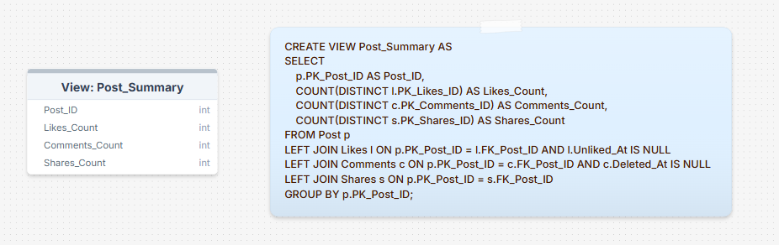

Post_Summary View Table helps us retrieve engagement statistics for posts. Firstly, I selected Post_ID from Post table and joined it with Likes, Comments and Shares Tables using LEFT JOIN, because I wanted to keep posts without interactions in the result set. Then used COUNT aggregate function to count the number of interactions related to each post, but only counting active interactions. This is done by making sure Unliked_At is NULL, and comments are counted only when Deleted_At is NULL. This prevents removed interactions from affecting the engagement statistics. Finally, the results are grouped by Post_ID using the GROUP BY clause, which allows database to calculate the total counts of likes, comments and shares for each individual post.

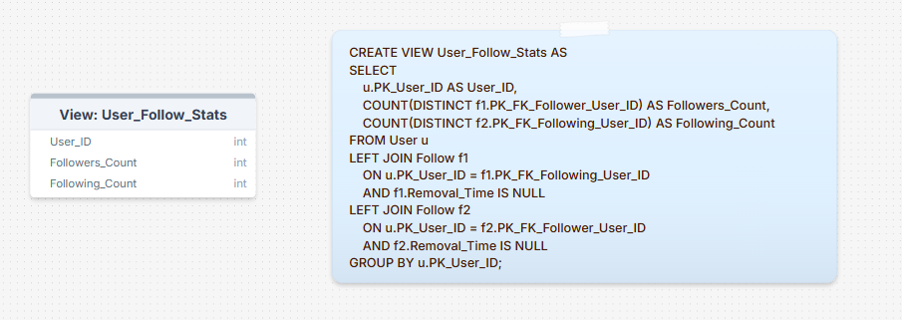

Social Media Platforms frequently display follower counts on user profile. By creating User_Follow_Stats View Table, it is simple for us to calculate these values directly from the Follow table. I selected the User_ID from the User Table and joined it with the Follow Table twice, using LEFT JOIN. First join (f1) connects the user to records where they appear as the user being followed, which allows the system to count how many followers that user has. The second join (f2) connects the user to records where they appear as the follower, and that allows system to count how many other users they follow. These are calculated with aggregate function COUNT and only active follow relationships are included, which is ensured by the condition Removal_Time is NULL. This prevents unfollowed relationships from being counted. Finally, the results are grouped by User_ID using GROUP BY. This allowes the database to calculate the follower and following count for each user individually.

Model description

Definitions & Acronyms
To answer these questions, you can rely on the following questions:
- Which key entities, roles, or processes require formal definitions for correct interpretation of the model?
- Which terms could be misunderstood without clarification?
- Which abbreviations or role names appear repeatedly in tables or relationships?

- As mentioned earlier, the User entity represents individuals who create accounts and interact with the platform. In the context of the database model, this entity functions as the central participant in most system activities. Users are responsible for creating content and performing different types of interactions, which is why many other tables in the schema reference the User table through foreign key relationships.

Another core component that was introduced previously is the Post entity. Posts represent the primary content created and shared by users within the platform. Many interactions in the system are centered around posts, including commenting, liking, sharing, and attaching additional elements such as media or hashtags. Because of this, several other entities are connected to the Post table in order to represent these interactions.

In addition to these main entities, the model also includes entities that represent different types of user actions or relationships. For example, tables such as Comments, Likes, Shares, and Follow describe interactions that occur between users and posts or between users themselves. These entities represent processes that occur within the platform rather than static objects, which is why they are modeled as separate tables.

Finally, I also created several supporting entities that define system attributes or categories, such as Media_Type, Visibility_Settings, and Share_Platform. These tables standardize specific values used across the system and help maintain consistency while allowing the model to remain flexible if additional options are introduced in the future.

- While designing the model, I noticed that some terms used in the schema could be interpreted differently without clarification. One example is the Profile entity. In my design, the Profile table is separated from the User table in order to distinguish between account-related information and personal user details. The User table stores the main account credentials and none of the attributes can be NULL and also are private and only accessible for the user itself, while the Profile table stores descriptive information such as the user’s name, biography, birth date or location and all of them, except First and Last Name, can be NULL. Also, Profile information is public and can be viewed by user’s followers. User Table and Profile Table have one-to-one relationship as each user can have only one profile.

Another term that may require clarification is Follow table, which represents the relationship between two users when one user befriends another user’s profile. Because this relationship includes two roles, the follower and the user being followed, it is important to clearly distinguish these roles within the schema. The Follow table is implemented as a self-referential relationship because both roles involved in the relationship belong to the same entity - the User table. In this case, one user references another user within the same table. I decided to implement this design, because social media platforms allow users to establish relationships with other users within the same system. The Follow table also acts as a bridge table that resolves a many-to-many relationship between users and users. A user can follow many other users, and at the same time a user can be followed by many users. To correctly represent this relationship, the Follow table uses a composite primary key consisting of the identifiers of both users involved in the relationship. Using a composite key ensures that each follow relationship is unique and prevents the same user from following the same account multiple times.

In addition to the Follow table, the model also includes another bridge table called Post_Hashtags. This table resolves the many-to-many relationship between posts and hashtags, since a single post can include multiple hashtags and a single hashtag can be associated with multiple posts. To represent this relationship correctly, the Post_Hashtags table uses a composite primary key composed of Post_ID and Hashtag_ID. Using a composite key ensures that each pair of post and hashtag appears only once in the table and prevents duplicate associations between the same post and hashtag.

The concept of Post Media may also need explanation. In this model, media refers to additional content attached to a post, such as images, videos or gifs, which is stored separately to allow a post to contain multiple media items. Similarly, Visibility Settings defines who is allowed to view a post within the platform. I chose to represent this type of several attributes that could have been implemented as ENUM data types by creating separate tables instead. Instead of defining ENUM values directly inside the columns, I created individual reference tables that store these pre-defined values and connected them through foreign key relationships. Examples of this approach include tables such as Media_Type, Visibility_Settings, and Share_Platform. Implementing ENUM-like attributes as separate tables provides greater flexibility, because new values can be added without altering the table structure. This approach also improves normalization and ensures that these attributes remain consistent across the system.

Providing these clarifications helps ensure that anyone analyzing the schema can correctly interpret the meaning of these entities and relationships.

- One of the most commonly used abbreviations in the schema is PK, which stands for Primary Key. I used this abbreviation to indicate the column that uniquely identifies each record in a table. Similarly, the abbreviation FK represents Foreign Key, which is used to indicate a column that references a primary key in another table. These abbreviations appear frequently throughout the schema because they define the relationships between entities.

The model uses consistent naming for identifier columns, such as User_ID, Post_ID. These names make it clear which entity a particular identifier belongs to and help maintain readability across the database structure.

Another naming pattern that appears repeatedly in the schema relates to datetime attributes. Many tables include columns such as Creation_Time, Deleted_At, Removed_At, Liked_At, or Shared_At. I intentionally used consistent naming for these datetime attributes to clearly indicate the moment when a specific action happened or when a record became inactive, but tried naming them differently for ach table for some more clarity. This approach helps preserve the history of user activities and supports traceability within the system.

Logical Scheme
<image>

Answer following questions:
- Which modeling decision was the most difficult and why?
- Provide examples of potential data anomalies that your design prevents. Explain which constraints or structure elements prevent them.
- If you were to add new attributes or participants, would the model remain scalable and why?
- Which part of your model would most likely change if requirements expand?

- One of the most challenging parts of designing the model was determining how to correctly represent relationships that involve multiple entities interacting with each other. As mentioned earlier, several relationships in the schema required the use of bridge tables and composite keys in order to properly model many-to-many connections between entities.

The difficulty was not only in implementing these structures, but also in identifying when they were necessary and how to organize them so that the relationships remained clear and logically consistent. During the design process, I had to carefully analyze how different entities interact within the platform and determine the most appropriate way to represent these interactions while maintaining normalization.

Although these decisions required additional consideration during the modeling process, they ultimately resulted in a more structured and better normalized schema.

- As already mentioned in the previous sections, the database structure was carefully designed to avoid common data anomalies and maintain consistent and reliable data. In this section, I summarize how the design decisions help prevent these issues.

One possible problem is duplicate data. For example, the same relationship or interaction could be recorded multiple times. To prevent this, I used primary keys and unique constraints, which ensure that each record is unique and cannot be duplicated.

Another potential issue is creating invalid references, where a record points to another record that does not exist. This could happen if relationships between tables were not properly controlled. To avoid this, I implemented foreign key constraints, which ensure that relationships between tables remain valid and that referenced records must already exist.

The design also prevents update anomalies, where the same piece of information would need to be changed in several places. In addition to the structural design, the use of constraints helps control what type of data can be stored in the database and ensures that records follow the logical rules defined in the model.

Finally, bridge tables help prevent problems when representing many-to-many relationships between entities. They allow these relationships to be stored in a clear and structured way without duplicating data.

- Yes, the model was designed to remain scalable if new attributes or participants need to be added in the future. As mentioned earlier, the schema follows 3NF and separates different concepts into individual tables. This structure reduces redundancy and allows new attributes or entities to be added without significantly modifying the existing tables.

In addition, the use of lookup tables and bridge tables makes the database flexible and easier to extend. For example, new interaction types, media formats, or platform options could be introduced by adding new records or tables rather than redesigning the entire schema. Because of this modular structure, the model can adapt to future changes while maintaining consistency and data integrity.

- If the system requirements expand in the future, the parts of the model that represent user interactions and content features would most likely change. Social media platforms often introduce new types of interactions, media formats, or content options over time.

For example, new interaction types or additional attributes related to posts and user activity could be added. However, because the model separates entities into independent tables and follows normalization principles, these changes could be implemented by extending existing tables or introducing new related tables without significantly modifying the core structure of the database.

Objects
Table Description:
- What real-world concept or event does this table represent?
- Why must this information be stored separately instead of inside another table?
- What is the normalization level of the table (1NF, 2NF, 3NF)? Explain your reasoning.
- Are there partial or transitive dependencies? How did you eliminate them? Which attributes depend only on the key, and which depend on other fields?
- Why did you choose this primary key (PK) for the table? Could a composite key work instead? Which foreign keys (FK) did you add and why?

Table Name | Field name | Field Description | Data Type
Table 1 | Field Name 1 | <description>, PK/FK | Int
 | Filed Name N | <description> | Text

Example with data (2-3 rows)

Field Name 1 | Field name 2 | Field name 3 | Field name N
1 | aaa | 123 | 1234

- User Table

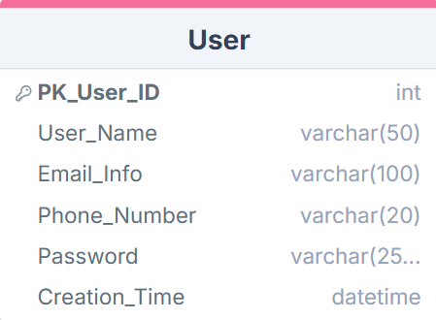

The User Table represents the main members of the Social Media Platform and the table stores the core information for individuals who register and interact with the system. It consists of essential data that is required for user identification and authentication at the log in. This table is referenced by many other entities in the database, including posts, comments, likes and follow relationships.
Each attribute describes the user account and solely depends on the Primary Key of the table. Data types in these case – VARCHAR is defined with a specific size limit, to allocate memory more effectively and avoid unnecessary use of storage space and it enforces data validation by preventing users from entering excessively long or invalid input.

Constraints:
PK_User_ID -This attribute is defined as the primary key of the table. It uniquely identifies each user in the system and ensures that every record in the table represents a distinct account.

NOT NULL: User_Name - Ensures that every user account has a username used for identification within the platform.
NOT NULL: Email_Info - Ensures that each account has an email address associated with it.
NOT NULL: Phone_Number - Ensures that a contact number is provided for each user account.
NOT NULL: Password - Ensures that authentication credentials are always stored for account access.
NOT NULL: Creation_Time - Ensures that the time of account creation is always recorded.

UNIQUE: User_Name - Prevents multiple users from having the same username.
UNIQUE: Email_Info - Ensures that each email address is used by only one user account.
UNIQUE: Phone_Number - Ensures that each phone number is associated with only one account.

DEFAULT: Creation_Time = CURRENT_TIMESTAMP - Automatically records the time when a user account is created if no value is provided.

Relationship
1. One-to-one relationship between User (User_ID) and Profile (FK_User_ID) -This relationship links each user account to a profile that stores additional personal information about the user.
2. One-to-many relationship between User (User_ID) and Post (FK_User_ID) - A user can create multiple posts, while each post belongs to exactly one user.
3. One-to-many relationship between User (User_ID) and Comments (FK_User_ID) - A user can write many comments, but each comment is associated with a single user.
4. One-to-many relationship between User (User_ID) and Likes (FK_User_ID) - A user can like many posts, while each like is recorded as an action performed by a specific user.
5. One-to-many relationship between User (User_ID) and Shares (FK_User_ID) - A user can share multiple posts, and each share record belongs to one user.
6. One-to-many relationship between User (User_ID) and Follow (FK_Follower_User_ID) - This relationship represents the users that a particular user follows.
7. One-to-many relationship between User (User_ID) and Follow (FK_Following_User_ID) - This relationship represents the users who follow a particular user.
(6.7) (Together, these two one-to-many relationships implement a many-to-many self-referential relationship between users through the Follow table, where one user can follow many users and one user can be followed by many others.)

PK_User_ID | User_Name | Email_Info | Phone_Number | Pasword | Creation_Time
1 | liziko_m | liziko@gmail.com | +995591330044 | Fvfvfvfvfvf!!! | 2026-03-10 14:22:31
2 | david_k | david@gmail.com | +995551112233 | isisisisisisis@@@ | 2026-03-11 09:15:12
3 | anna_g | anna@gmail.com | +995557454545 | Sdfghhgfdfg!!! | 2026-03-12  18:07:21

- Profile Table

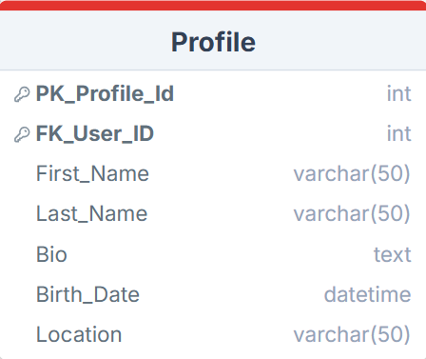

The Profile Table represents an additional personal information that is associated with a user account and this table attributes can be seen by other users publicly. Storing this information separately helps distinguish account credentials and personal profile information. And unlike User Table attributes, Bio, Birth_Date and Location can be NULL here. Each attribute, describes only the profile information and depends entirely on the Primary Key. As stated before, relationship between User Table and Profile Table in One-to-one, as a person can not create two profiles with the same user information.

Constraints
PK_Profile_ID - This attribute is defined as the primary key of the table. It uniquely identifies each profile record and ensures that every profile stored in the table is distinct.

FK_User_ID - This attribute is defined as a foreign key that references User.PK_User_ID. It ensures that every profile is associated with an existing user account in the system and prevents profiles from being created without a corresponding user.

NOT NULL: First_Name - Ensures that each profile contains the user’s first name, which is required as part of the basic profile information.
NOT NULL: Last_Name - Ensures that each profile contains the user’s last name, completing the main identifying information of the profile.

UNIQUE: FK_User_ID – Prevents one user to have multiple profiles.

Relationship
One-to-one relationship between Profile (FK_User_ID) and User (PK_User_ID) - Each profile belongs to exactly one user account, and this relationship connects profile information with the corresponding user in the system.

PK_Profile_ID | FK_User_Id | First_Name | Last_Name | BIo | Birth_Date | Location
1 | 1 | Liziko | Mamaladze | Data Analyst | 2005-10-04 | Guramishvili Avenue12
2 | 2 | David | Kapanadze | Photographer | 2002-05-19 | Chavchavadze Avenue 12
3 | 3 | Anna | Gelashvili | Designer | 2003-08-11 | Tamarashvili Avenue 15

- Follow Table

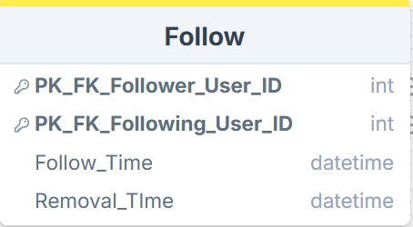

The Follow table represents the relationship between users, when one user follows another user on the social media platform. This table stores pairs of users that are connected through a follow relationship and records when the relationship was created or removed. Attributes such as Follow_Time and Removal_Time, allow the system to track the history of follow interactions.
I decided to store this information in a separate table because the relationship between users is many-to-many: one user can follow many other users, and one user can also be followed by many users. To properly represent this relationship while maintaining normalization, the Follow table acts as a bridge table that connects users to other users.
Using composite primary key consisting of Follower_User_ID and Following_User_ID ensures that each follow relationship between two users is unique and prevents duplicate follow records. Both attributes are also foreign keys referencing User.PK_User_ID, which ensures that every follow relationship always connects two existing users in the system.

Constraints
Composite Primary Key: (PK_FK_Follower_User_ID, PK_FK_Following_User_ID) - These two attributes together form a composite primary key of the table. This ensures that each follow relationship between two users is unique and prevents the same user from following another user more than once.

FK: PK_FK_Follower_User_ID - This attribute is defined as a foreign key referencing User.PK_User_ID. It ensures that the user performing the follow action exists in the system.
FK: PK_FK_Following_User_ID - This attribute is defined as a foreign key referencing User.PK_User_ID. It ensures that the user being followed exists in the system.

NOT NULL: Follow_Time - Ensures that the system records the exact time when the follow relationship was created.

DEFAULT: Follow_Time = CURRENT_TIMESTAMP - Automatically assigns the current timestamp when a user follows another user.

Follow.PK_FK_Follower_User_ID ≠ Follow.PK_FK_Following_User_ID – Makes sure a user can not follow themselves.

Relationships
1. One-to-many relationship between User (PK_User_ID) and Follow (PK_FK_Follower_User_ID) - This relationship represents the users who initiate follow actions, where one user can follow many other users.
2. One-to-many relationship between User (PK_User_ID) and Follow (PK_FK_Following_User_ID) - This relationship represents the users being followed, where one user can be followed by many other users.

PK_FK_Follower_User_ID | PK_FK_Following_User_ID | Follow_Time | Removal_Time
1 | 2 | 2026-03-10 | NULL
3 | 1 | 2026-03-11 | NULL

- Post Table

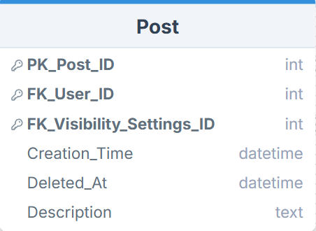

The Post table represents the main content created by users on the social media platform. This table stores information related to each post, including the user who created it, the visibility settings applied to the post, the time it was created, and the textual description associated with the content. Since posts are the central objects that users interact with through likes, comments, shares, media attachments, and hashtags, this table serves as a key component of the system. Each attribute describes only the post itself and depends entirely on the primary key of the table. There are no partial or transitive dependencies since attributes such as creation time, description, and visibility settings all relate directly to the post. As post can be private, public or intended for only followers, decided to separate visibility into lookup table to reduce repetitive information. Description attribute is TEXT data type, as it allows storage for long and variable length content without requiring a fixed maximum size like VARCHAR.

Constraints
PK: Post_ID - This attribute is defined as the primary key of the table. It uniquely identifies each post in the system and ensures that every post record is distinct.

FK: FK_User_ID - This attribute is defined as a foreign key referencing User.PK_User_ID. It ensures that every post is associated with an existing user who created the content.
FK: FK_Visibility_Settings_ID - This attribute is defined as a foreign key referencing Visibility_Settings.PK_Visibility_Settings_ID. It ensures that each post has a valid visibility setting that determines who can view the post.

NOT NULL: Creation_Time - Ensures that the system records the exact time when the post was created.
Relationships
1. One-to-many relationship between User (PK_User_ID) and Post (FK_User_ID) - A user can create multiple posts, while each post is associated with exactly one user who created the content.
2. One-to-many relationship between Visibility_Settings (PK_Visibility_Settings_ID) and Post (FK_Visibility_Settings_ID) - Each post is assigned one visibility setting that defines who is allowed to view the post, while the same visibility setting can be applied to multiple posts.
3. One-to-many relationship between Post (PK_Post_ID) and Comments (FK_Post_ID) - A post can receive many comments from users, while each comment belongs to a single post.
4. One-to-many relationship between Post (PK_Post_ID) and Likes (FK_Post_ID) - A post can receive many likes from different users, while each like is associated with a single post.
5. One-to-many relationship between Post (PK_Post_ID) and Shares (FK_Post_ID) - A post can be shared multiple times by different users, while each share record references a single post.
6. One-to-many relationship between Post (PK_Post_ID) and Post_Media (FK_Post_ID) - A post can contain multiple media items such as images or videos, while each media record belongs to a single post.
7. Many-to-many relationship between Post and Hashtags implemented through the Post_Hashtags bridge table - A post can be associated with multiple hashtags, and a hashtag can appear in many posts. This relationship is implemented through two one-to-many relationships: Post (PK_Post_ID) to Post_Hashtags (FK_Post_ID), and Hashtags (PK_Hashtags_ID) to Post_Hashtags (FK_Hashtags_ID).

PK_Post_ID | FK_User_ID | FK_Visibility_Settings_ID | Creation_Time | Deleted_At | Description
1 | 1 | 1 | 2026-03-10 14:22:05 | NULL | Sunset in Tbilisi
2 | 2 | 1 | 2026-03-10 14:25:35 | NULL | Weekend trip
3 | 3 | 2 | 2026-03-11 09:15:40 | NULL | New design project

- Post_Media Table

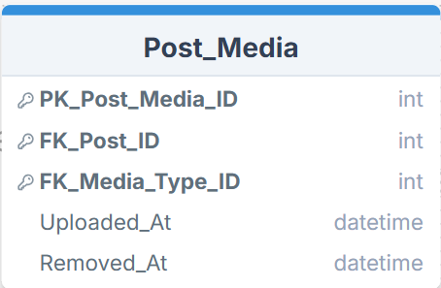

The Post_Media table represents media content attached to posts on the social media platform. This table stores information about media files such as images or videos that are associated with a specific post. It includes attributes that record the post to which the media belongs, the type of media, and the timestamps indicating when the media was uploaded or removed. It is different from post, as the media can be changed or deleted without removing the post entirely. So, it is important to separate the two. Single post can contain multiple media items, and storing media information directly inside the Post table would lead to redundancy and limit the number of media files a post could contain. Each attribute describes only the media record and depends entirely on the primary key of the table.

Constraints
PK: Post_Media_ID - This attribute is defined as the primary key of the table. It uniquely identifies each media record attached to a post and ensures that every entry in the table is distinct.

FK: FK_Post_ID - This attribute is defined as a foreign key referencing Post.PK_Post_ID. It ensures that each media item is associated with an existing post in the system.
FK: FK_Media_Type_ID - This attribute is defined as a foreign key referencing Media_Type.PK_Media_Type_ID. It ensures that every media item is assigned a valid media type, such as image or video.
NOT NULL: Uploaded_At - Ensures that the system records the exact time when the media item was uploaded.

DEFAULT: Uploaded_At = CURRENT_TIMESTAMP - Automatically records the time when the media item is uploaded if no value is provided.

Relationships
1. One-to-many relationship between Post (PK_Post_ID) and Post_Media (FK_Post_ID) - A post can contain multiple media items, such as images or videos, while each media record is associated with exactly one post.
2. One-to-many relationship between Media_Type (PK_Media_Type_ID) and Post_Media (FK_Media_Type_ID) - Each media item is assigned a specific media type, while the same media type (for example image or video) can be used by many media records across different posts.

PK_Post_Media_ID | FK_Post_ID | FK_Media_Type_ID | Uploaded_At | Removed_At
1 | 1 | 1 | 2026-03-10 14:25:10 | NULL
2 | 1 | 2 | 2026-03-10 14:26:35 | NULL
3 | 2 | 1 | 2026-03-11 09:18:42 | 2026-03-12 10:05:12

- Media_Type Table

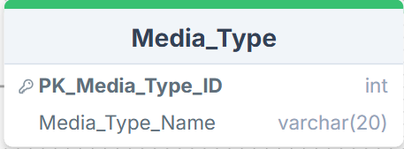
The Media_Type is a lookup table and stores the different types of media that can be attached to posts on the platform, such as images or videos. Instead of storing media type names directly in other tables, I created this separate table so that media types can be referenced through a foreign key, which helps maintain consistency and avoids repeated text values across the database. This way it is easier to edit, add or delete media types and have it added without modifying the structure of other tables.

Constraints
PK: Media_Type_ID - This attribute is defined as the primary key of the table. It uniquely identifies each media type stored in the system.

NOT NULL: Media_Type_Name - Ensures that every media type record has a name describing the type of media.

UNIQUE: Media_Type_Name - Ensures that each media type name appears only once in the table, preventing duplicate media categories such as multiple records for the same type.

Relationships
1. One-to-many relationship between Media_Type (PK_Media_Type_ID) and Post_Media (FK_Media_Type_ID) - Each media type can be associated with many media records attached to posts, while each media record belongs to exactly one media type.

PK_Media_Type_ID | Media_Type_Name
1 | Image
2 | Video
3 | Gif

- Post_Hashtag Table

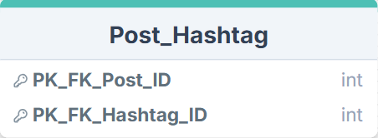

The Post_Hashtag table represents bridge table, the relationship between posts and hashtags used within the platform. This table records which hashtags are associated with each post. I created this table because the relationship between posts and hashtags is many-to-many: a single post can include multiple hashtags, and the same hashtag can appear in many different posts. So, using composite key ensures that each post–hashtag pair is unique and prevents the same hashtag from being assigned to the same post multiple times. Both attributes are also foreign keys that reference Post.PK_Post_ID and Hashtags.PK_Hashtag_ID, ensuring that each relationship always connects existing posts and hashtags.

Constraints
Composite Primary Key: (FK_Post_ID, FK_Hashtag_ID) - These two attributes together form a composite primary key. This ensures that each combination of a post and a hashtag appears only once in the table and prevents duplicate hashtag assignments for the same post.

FK: FK_Post_ID - This attribute is defined as a foreign key referencing Post.PK_Post_ID. It ensures that every record in the table is associated with an existing post.

FK: FK_Hashtag_ID - This attribute is defined as a foreign key referencing Hashtags.PK_Hashtags_ID. It ensures that every record in the table references a valid hashtag stored in the system.

Relationships
Already explained in the Post Table Relationships.

PK_FK_Post_ID | PK_FK_Hashtag_ID
1 | 1
1 | 2
2 | 3

- Hashtag Table

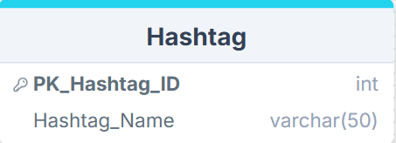
The Hashtag table stores the hashtags that can be used within posts on the platform. So, it is a lookup table. Hashtags represent keywords or tags that help categorize and organize content, making it easier for users to discover posts related to specific topics. Each hashtag stored in this table can be associated with multiple posts. I created this table separately to avoid repeating hashtag text values in the database and to maintain a consistent structure. Instead of storing hashtags directly inside the Post table, they are stored in their own table and connected to posts through the Post_Hashtag bridge table. This design supports the many-to-many relationship between posts and hashtags while preventing redundant data.

Constraints
PK: Hashtag_ID - This attribute is defined as the primary key of the table. It uniquely identifies each hashtag stored in the system.

NOT NULL: Hashtag_Name - Ensures that every hashtag record contains a name describing the hashtag.

UNIQUE: Hashtag_Name - Ensures that each hashtag name appears only once in the table, preventing duplicate hashtags from being created.

Relationships
1. One-to-many relationship between Hashtag (PK_Hashtag_ID) and Post_Hashtag (FK_Hashtag_ID) - A single hashtag can be associated with many posts through the Post_Hashtag bridge table, while each record in Post_Hashtag references one specific hashtag. Together with the relationship between Post and Post_Hashtag, this forms a many-to-many relationship between Post and Hashtags.

PK_Hashtags_ID | Hashtags_ID
1 | travel
2 | sunset
3 | photography

- Visibility_Setting Table

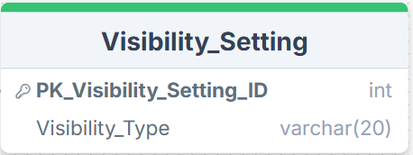

The Visibility_Setting table is also a lookup table and stores the different visibility options that determine who is allowed to view a post on the platform. These settings define the access level of a post, such as whether it is visible to all users, only followers, or restricted in another way. Each post references one visibility setting that controls how the content can be accessed. I created this table as a lookup table to store predefined visibility options instead of writing visibility values directly in the Post table. This approach makes it easier to add new visibility options in the future without changing the structure of other tables.

Constraints
PK: Visibility_Setting_ID - This attribute is defined as the primary key of the table. It uniquely identifies each visibility setting stored in the system.

NOT NULL: Visibility_Type - Ensures that every visibility setting has a defined name describing the type of access level.

UNIQUE: Visibility_Type - Ensures that each visibility type appears only once in the table, preventing duplicate visibility categories from being created.

Relationships
1. One-to-many relationship between Visibility_Settings (PK_Visibility_Settings_ID) and Post (FK_Visibility_Settings_ID) - Each visibility setting can be applied to many posts, while each post references exactly one visibility setting that determines who is allowed to view the post.

PK_Visibility_Settings_ID | Visibility_Type
1 | Public
2 | Folowers
3 | Private

- Like Table

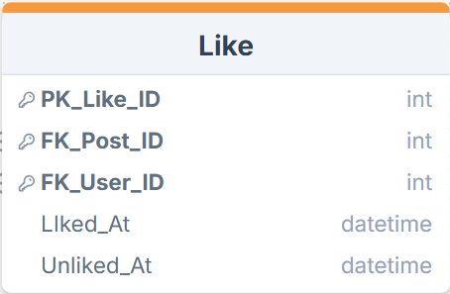

The Like table represents the interaction where a user expresses approval or appreciation for a post. This table stores records of users liking posts on the platform and tracks when the like action occurred. Each record connects a specific user with a specific post. I created this table separately because liking a post represents a user interaction event rather than a static property of the post itself. Storing likes in their own table allows the system to record many likes for a single post and also track which user performed the action.

Constraints
PK: Like_ID - This attribute is defined as the primary key of the table. It uniquely identifies each like record stored in the system.

FK: FK_Post_ID - This attribute is defined as a foreign key referencing Post.PK_Post_ID. It ensures that each like is associated with an existing post.
FK: FK_User_ID - This attribute is defined as a foreign key referencing User.PK_User_ID. It ensures that each like is performed by an existing user in the system.

NOT NULL: Liked_At - Ensures that the time when the like action occurred is always recorded.

DEFAULT: Liked_At = CURRENT_TIMESTAMP - Automatically assigns the current timestamp when a user likes a post if no value is provided.

UNIQUE: (Like.FK_Post_ID, Like.FK_User_ID) – Appling UNIQUE constraint on these two columns together makes sure that the combination is unique, meaning, one user can not like same post multiple times.

Relationships
1. One-to-many relationship between User (PK_User_ID) and Likes (FK_User_ID) - A user can like many posts, while each like record is associated with exactly one user who performed the action.
2. One-to-many relationship between Post (PK_Post_ID) and Likes (FK_Post_ID) - A post can receive many likes from different users, while each like record references a single post.

PK_Likes_ID | FK_Post_ID | FK_User_ID | Liked_At | Unliked_At
1 | 1 | 2 | 2026-03-10 14:30:12 | NULL
2 | 1 | 3 | 2026-03-10 14:31:45 | NULL
3 | 2 | 1 | 2026-03-10 14:31:45 | 2026-03-12 08:15:00

- Share Table

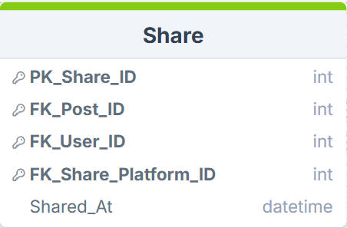

The Share table represents the interaction where a user shares a post on the platform or to another platform. This table stores records of sharing actions and tracks which user shared which post, as well as the platform where the post was shared, which is represented by Share_Platform lookup table. I created Share table separately because sharing is a user interaction event related to posts, similar to likes and comments. Storing this information in its own table allows the system to record multiple share actions for the same post and track which user performed the action.

Constraints
PK: Shares_ID - This attribute is defined as the primary key of the table. It uniquely identifies each share record stored in the system.

FK: FK_Post_ID - This attribute is defined as a foreign key referencing Post.PK_Post_ID. It ensures that each share action is associated with an existing post.
FK: FK_User_ID - This attribute is defined as a foreign key referencing User.PK_User_ID. It ensures that each share action is performed by an existing user.
FK: FK_Share_Platform_ID - This attribute is defined as a foreign key referencing Share_Platform.PK_Share_Platform_ID. It ensures that the share action references a valid platform where the post is shared.

NOT NULL: Shared_At - Ensures that the time when the share action occurred is always recorded.

DEFAULT: Shared_At = CURRENT_TIMESTAMP - Automatically assigns the current timestamp when a share action is created if no value is provided.
Relationships
1. One-to-many relationship between User (PK_User_ID) and Shares (FK_User_ID) - A user can share many posts, while each share record is associated with exactly one user who performed the action.
2. One-to-many relationship between Post (PK_Post_ID) and Shares (FK_Post_ID) - A post can be shared multiple times by different users, while each share record references a single post.
3. One-to-many relationship between Share_Platform (PK_Share_Platform_ID) and Shares (FK_Share_Platform_ID) - Each share platform can be used in many share records, while each share record references one specific platform where the post was shared.

PK_Shares_ID | FK_Post_ID | FK_User_ID | FK_Share_Platform_ID | Shared_At
1 | 1 | 2 | 1 | 2026-03-10 14:40:15
2 | 2 | 1 | 2 | 2026-03-11 09:35:22
3 | 1 | 3 | 3 | 2026-03-12 11:10:05

- Share_Platform Table

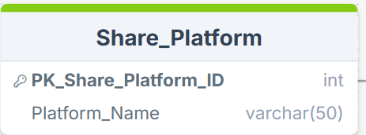

The Share_Platform table serves as lookup table and stores the different platforms where posts can be shared from the system. It also allows new platforms to be added easily without modifying the structure of other tables. These platforms represent external or internal destinations where users may distribute content. Each platform stored in this table can be referenced when a user shares a post.
Constraints
PK: Share_Platform_ID - This attribute is defined as the primary key of the table. It uniquely identifies each sharing platform stored in the system.

NOT NULL: Platform_Name - Ensures that every share platform record has a defined name describing the platform.

UNIQUE: Platform_Name - Ensures that each platform name appears only once in the table, preventing duplicate platform entries.

Relationships
1. One-to-many relationship between Share_Platform (PK_Share_Platform_ID) and Shares (FK_Share_Platform_ID) - Each sharing platform can be associated with many share records, while each share record references one specific platform where the post was shared.

PK_Share_Platform_ID | Platform_Name
1 | Facebook
2 | Instagram
3 | Twitter

- Comments Table

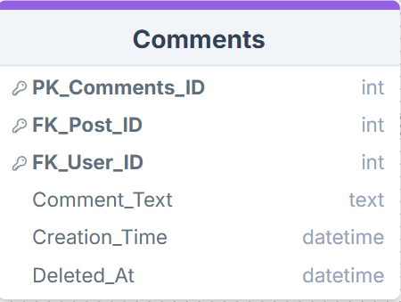
The Comments table represents the interaction where users leave textual responses on posts within the platform. This table stores information about each comment, including the post it belongs to, the user who wrote it, the comment content, and the time when the comment was created. Since comments are a form of user interaction with posts, they are stored separately from the Post table. I created this table as a separate entity because a single post can receive multiple comments from different users, and a single user can also write comments on many posts. Storing comments in their own table allows the system to track each interaction individually while maintaining a clear structure and avoiding redundant data. Foreign keys FK_Post_ID and FK_User_ID, which connect each comment to the post it belongs to and to the user who created it.

Constraints
PK: Comments_ID - This attribute is defined as the primary key of the table. It uniquely identifies each comment stored in the system.

FK: FK_Post_ID - This attribute is defined as a foreign key referencing Post.PK_Post_ID. It ensures that each comment is associated with an existing post.
FK: FK_User_ID - This attribute is defined as a foreign key referencing User.PK_User_ID. It ensures that each comment is written by an existing user in the system.

NOT NULL: Comment_Text - Ensures that every comment contains textual content.
NOT NULL: Creation_Time - Ensures that the time when the comment was created is always recorded.

DEFAULT: Creation_Time = CURRENT_TIMESTAMP - Automatically assigns the current timestamp when a comment is created if no value is provided.
Relationships
1. One-to-many relationship between User (PK_User_ID) and Comments (FK_User_ID) - User can create many comments on different posts, while each comment is associated with exactly one user who wrote it.
2. One-to-many relationship between Post (PK_Post_ID) and Comments (FK_Post_ID) - A post can receive many comments from different users, while each comment belongs to a single post.

PK_Comments_ID | FK_Post_ID | FK_User_ID | Comment_Text | Creation_Time | Deleted_At
1 | 1 | 2 | Amazing photo! | 2026-03-10 14:35:20 | NULL
2 | 1 | 3 | Love this view | 2026-03-10 14:36:45 | NULL
3 | 2 | 1 | Great post! | 2026-03-11 09:25:10 | 2026-03-11 10:05:00

